Lomonosov Moscow State University
Faculty of Global Processes

Dr. Yury N. Sayamov

Diplomacy and diplomatic service in the globalizing world

Сourse Guide

Moscow
2014

This course guide is intended for students and post graduates of the Lomonosov Moscow State University and of other higher educational establishments, especially for those who wish to specialize in geopolitics and diplomacy and are going to dedicate their future to the practical work in the area of international relations.
It is a kind of itinerary to the course "Diplomacy and diplomatic service in the globalizing world" which is taught for the students of the Faculty of Global Processes of the Lomonosov Moscow State University during one semester in the amount of 16 lectures (32 hours) combined with practical studies.
For outdoor lectures students are going to visit the Center of the History of the Russian Diplomacy at the Ministry of Foreign Affairs of the Russian Federation where students will be given the opportunity to get acquainted with historical materials, samples of diplomatic documents, supplies, uniforms and diplomats’ insignia from different eras.
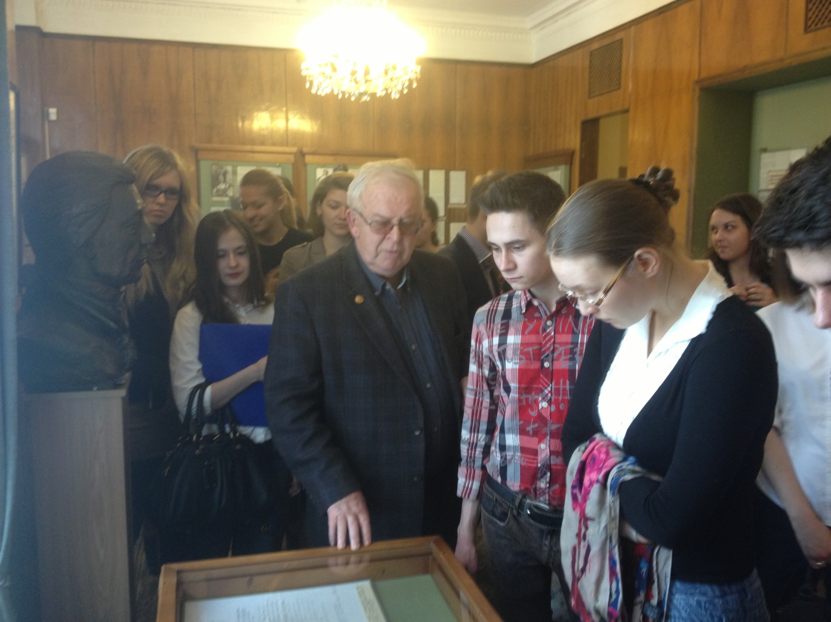
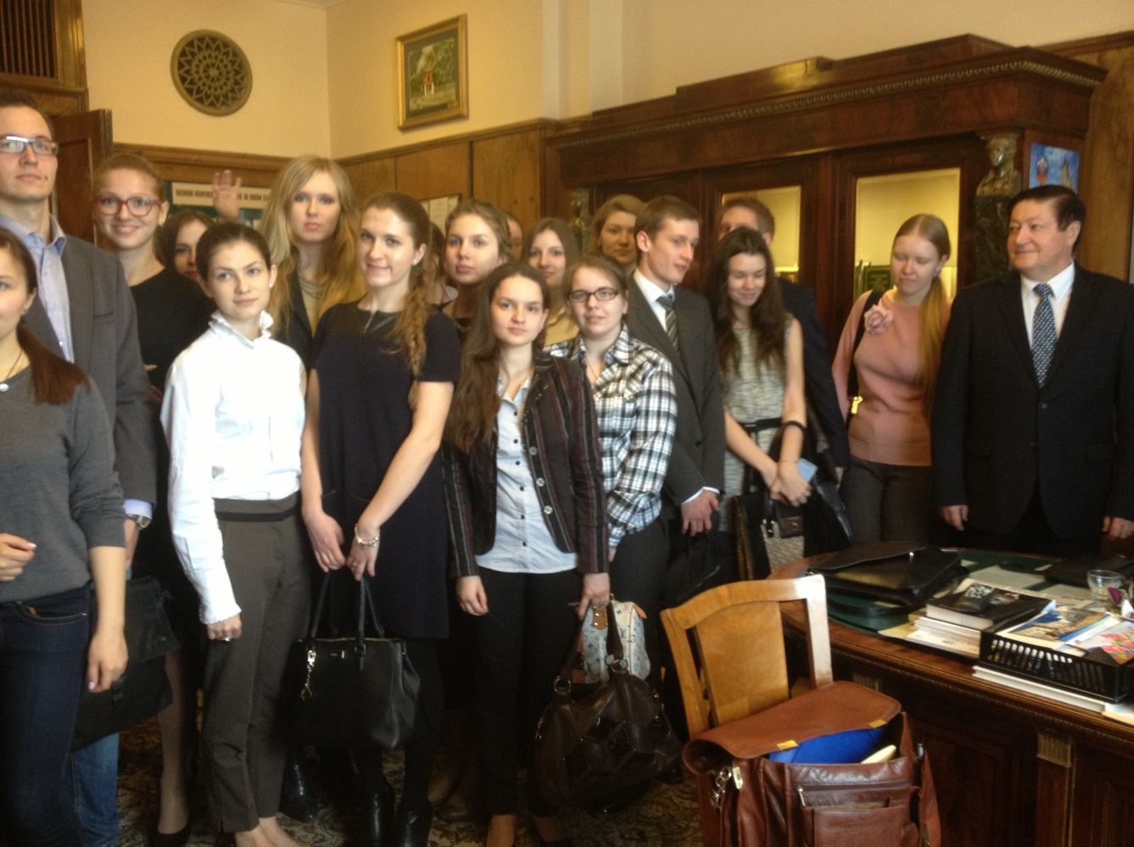
Outdoor lecture for students of the Faculty of Global Processes of the Lomonosov Moscow State University in the Center of the History of the Russian Diplomacy at the Ministry of Foreign Affairs of the Russian Federation. The lecture is given by the Director of the Center Ambassador Yury M. Khilchevsky.
The Open Classes serve as an addition to the course. They are held by the Faculty of Global Processes and the UNESCO Chair at the Faculty jointly with the Association of Russian Diplomats – a public organization at the Ministry of Foreign Affairs of the Russian Federation uniting acting and retired diplomats, national diplomacy veterans. Lectures are delivered by outstanding diplomats, experts in international law, representatives of state and public organizations dealing with international relations who share their unique experience with students.
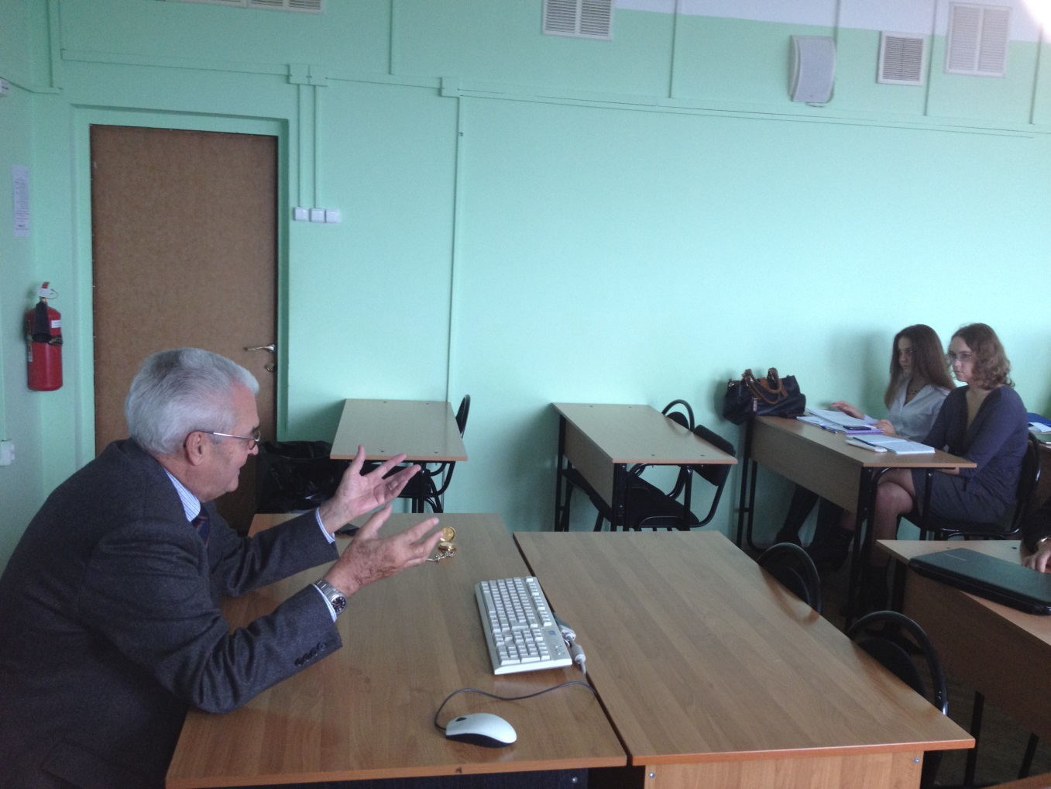
Prominent Russian and Foreign diplomats addressing students of the Faculty of Global Processes of the Lomonosov Moscow State University in the Open classes. Ambassador Igor I.Studennikov lecturing on Africa and former Assistant Director General of UNESCO Thomas Keller sharing with students his experience.

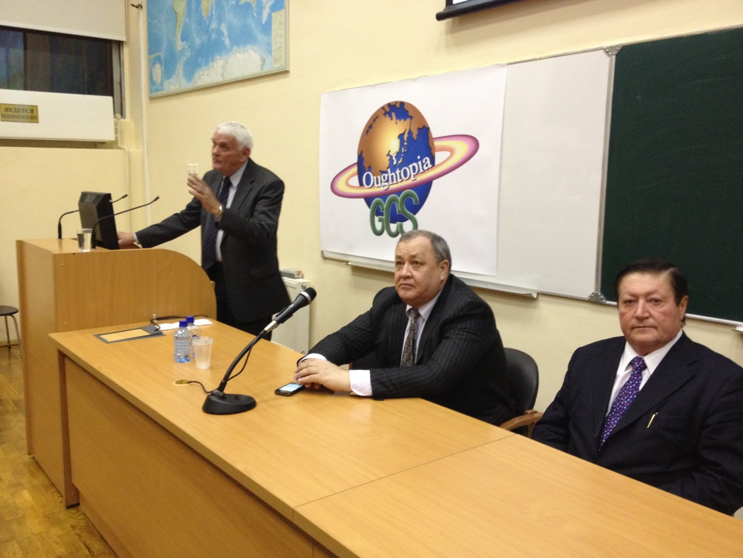
The "Diplomacy and diplomatic service in the globalizing world" is an innovative course. It aims to interlink the necessary basis of discipline mandatory when preparing specialists in the area of international relations that open for them job prospects in diplomatic service, with the main content taught at the Faculty of Global Processes thus providing a unique education in the field of international relations with the knowledge of global problems and the competence in global issues.
The course guide includes introduction, educational and thematic plan, the "Diplomacy and diplomatic service in the globalizing world" course outline, approximate themes and subjects for annual student scientific works, questions for the final assessment of the academic progress in the course, the list of recommended books, as well as the list of key concepts and terms used in diplomacy.

Introduction.

The course "Diplomacy and diplomatic service in the globalizing world" is committed to provide students with the basics of diplomacy and diplomatic service necessary for their subsequent practical work and scientific research in the context of global processes affecting the world.
The President of the Russian Federation Vladimir Putin speaking at the meeting of ambassadors and permanent representatives of the Russian Federation pointed out that international relations are getting ever more complex undergoing a rapid transformation. Under these conditions, the ability to quickly and competently analyze what is happening e world and make timely forecast become extremely important. At the same time, he emphasized, it is insufficient to passively observe the situation. It is necessary to actively influence it whenever the interests of the country are touched, to act proactive, to be prepared for any variant of the situational development, even to the most negative variant of such a development.*
In order to correspond to high requirements of our time, the specialists in the sphere of the foreign policy should possess the necessary grounding for the successful pursuit of their activities combining analytical and research thinking, the knowledge of the practical work organization, the ability to apply the existing rich arsenal of international communication methods and means and the desire to supplement them with the personal creative participation.
Taking into account that the basic knowledge of diplomacy and diplomatic service is a qualification requirement for the work in the diplomatic sphere and is essentially necessary for anyone who would like to become a specialist in international relations, the proposed course aims to provide students with the knowledge of the subject in the volume needed for its understanding and practical usage.
In the sense that the history of diplomacy is an independent subject, the proposed course aims at teaching rather not historical, but preferentially practical components of diplomacy.
The proposed course pays a special attention to the consideration of the issues of diplomacy and diplomatic service in close relation with problems of the globalizing world and the objectives put forward by the new foreign policy concept of the Russian Federation.

* Vladimir Putin. Speech at the meeting of Russian Federation ambassadors and permanent representatives at the International Organizations, July 9, 2012. "International Affairs”, No. 7, 2012, page 2.

For the notion of diplomacy characterized by various authors and dictionaries from different epochs as:
- "intelligence and tact application in the intergovernmental affairs carried out by peaceful means" (E. Satou, British diplomat, the author of "A Guide to Diplomatic Practice");
- "conducting of international relations using negotiations, diplomatic skills and work" (Oxford Dictionary);
- "policy in a luxurious suit" (Napoleon);
- "the best means ever used by the civilization to prevent the force from governing international relations" (Henry de Broble, French writer and diplomat, French Ambassador in London);
- “the ability to communicate, negotiate and persuade" (Lord Lyon, the British envoy in Washington during the American Civil War);
- "fundamental activities by heads of states, governments and special authorities in the field of international relations aimed at the implementation of foreign policy goals and objectives, as well as at the protection of rights and interests of the state abroad". (The USSR Diplomatic Dictionary),
the course offers its own author's definition:
"Diplomacy is both the science and the art of carrying out foreign relations by peaceful means and legal methods to ensure effective representation, defense and promotion in the world of the interests of the state and its citizens, or the interests of the organizations and their members, by making use of contacts, meetings, discussions, negotiations, conferences, information collection and analytical evaluation, its exchange with partners and of other instruments of international cooperation, the ability and skills to communicate and persuade on purely legal and mutually respectful professional basis, determined by the provisions of the UN Charter and settled down by respective international treaties and conventions."
Diplomacy is often identified with international relations, though diplomacy, being undoubtedly an integral part of the latter, stands out – according to the definition proposed in the fundamental work "The History of Diplomacy" - as "the formalized quintessence” of the international relations, a kind of its superstructure.*
By their structure and content the contemporary international relations show a great variety and extreme complexity. Nowadays, in a way or another, they involve hundreds of millions of people of different professions, ages, occupations and interests.
__________________________________________
*The History of Diplomacy: (Collect.) / Comp. A.Laktionov. - M., ACT, 2005
In the course of the international relations development international associations and organizations have emerged and quickly grown in size and number. Major cities, political and social movements, non-governmental organizations declared themselves as self-reliant participants in world affairs. Chiefs and kings diplomacy has changed to the diplomacy of states and nations later complemented by the public diplomacy that occupies today by far not the last place on the world stage.
As particular streams economic diplomacy, corporations diplomacy, fuel and energy diplomacy have been formed. International contacts at all levels unprecedentedly expanded due to the development of various means of transport and communication.
Apparently, it is not accidental that even a lot of authoritative encyclopedias and reference books do not contain any definitions of international relations what can be, to a certain extent, explained by their diversity and complexity. On this background it is ever more valuable that the authors of the textbook "International Relations" edited by Professor P. A. Tsygankov managed to found the following compact and legible formulation: "International relations are diverse factors, events, processes, standards and flows crossing national-state borders"* which is taken as a basic one for this course.
The dividing line between the domestic and the foreign policy is becoming increasingly transparent as global processes and common development trends determinate in the growing extent the internal political development in countries, cities and regions.
While exploring the interconnection between the domestic and the international issues within the world politics it is necessary to mention that the world order based on the cooperation of states and on the balance of their forces is being replaced by the new international relations which include non-governmental sector, cities, local governments and other participants that have more insistently than ever asserted themselves on the world stage and have significantly changed international communication environment. That is why the nature of diplomacy and diplomatic communication is also changing, as well as the diplomatic service.
Although the states still remain the main actors and performers in the complex global diplomacy play, they are not any more the only figures on the desk of international relations and therefore while examining the interstate cooperation together with the official diplomacy as its main instrument, it is necessary at the same time to pay attention to the analysis of the influence of non-governmental participants that have an important role in the international affairs nowadays and come out with their often very efficient variants of diplomacy - national, municipal (which pretends to be closer to people and respectively more representative), city diplomacy, global civil society diplomacy, transnational diplomacy etc.
__________________________________________
* International relations: theory, conflicts, movements, organizations. / P. A. Tsygankov, G. A. Drobot, M. M. Lebedeva, etc. / Edited by Prof. P. A. Tsygankov: Textbook. The 2nd edition – rev. and add. - Moscow, 2009.
Going over to the definition of global processes, it is necessary to mention, that the course uses formulations from the work of the Dean of the Faculty of Global Processes of the Lomonosov Moscow State University, professor Ilya V. Ilyin "Theoretical and methodological fundamentals of globalistics" * where global processes are characterized as "one of the key categories not only of globalistics, but also of the whole modern scientific discourse" and is noted that "almost all scientific disciplines nowadays deal, to a certain extent, with global processes."
While asking ourselves what is the content of this category, which properties of the objective world it reflects and what is the subjective side of this notion, the author states, that "in the most general way global processes can be defined as successive changes in the state of natural and social systems which functioning can be applied to the planet as a whole."
Global processes in this work are conventionally divided into three main groups:
- Global natural processes, i.e. processes that alter the global physical structure, the stagnant and living matter.
- Global social processes, i.e. processes that alter the global social relations structure.
- Global socio-natural processes, i.e. processes of interaction between the society and the nature.
The first group includes processes of changes in atmospheric, mineral, biological, water, climate, and other physical characteristics of the planet.
The second group includes processes of changes in political, economic, social, cultural, legal, ideological, moral, spiritual and other relations of people.
The third group includes environmental, natural resource and other socio-natural interactions connecting processes of the first and of the second groups into the integrated global system.
Global processes, globalization as a global development trend, global studies as the science of global processes and phenomena became a part of the active socio-political lexicon just a few decades ago and gradually established themselves on the international arena as its integral and increasingly important components. Does it mean that they did not exist earlier?
____________________________________________________________
* I.V.Ilyin. Theoretical and methodological fundamentals of globalistics. Moscow,
2009.

Modern public and scientific concepts contain a sufficiently large amount of opinions regarding the origin and history of these processes, as well as the standpoints, concerning their nature and characteristic features. Anyway, we have to agree that global processes are objective in their nature and had appeared long before the time when scientific thought identified them as a global category. And if nowadays no one has doubts in the fact of the actual ongoing global processes existence, there are still debates concerning historical borders of globalization, regarded as a social phenomenon.
The terms “global problems of the contemporary time" in the national political and scientific usage and "globalization" - mainly abroad – appeared in the 60s of the XX century, at the end of which globalization became a prevalent trend in the world development directly affecting changes in the structure and in the content of global relations, including those in the diplomatic sphere.
There is, however, a point of view, that the modern wave of globalization is the second one, and the first one relates to the turn of the XIX - XX centuries when, according to the results of the modern historical research, many similar, to a certain extent, processes, took place.
Nevertheless, if we agree with the definition of the recognized authority in the field of global studies, professor R. Robertson of the Aberdeen University, our world since 1969 entered the phase of a global uncertainty.
Back to the same period is dated the beginning of the scientific understanding of globalization processes in the sphere of international relations and diplomacy accompanied by respective adjustments in practical activities.
Among the most popular theoretical models used to explain globalization processes in the late 80s of the last century, it can be specified, in particular, the modernization theory attempting to prove the necessity and the possibility of the introduction of the modernist ideology and practice into the less developed countries in order to achieve their progress. It was based on the theory of modernism that emerged, according to R. Robertson, during the initial globalization development in the late 19th and early 20th centuries, as well as on the modernist consciousness which was in all its different variations consistently associated throughout the XX century with the contradictory globalization process.
Global civilization process, in international relations including, could be considered in this context as a sequential transformation of traditional civilizations into innovative ones. In this case, the country’s incorporation into the world intellectual and economic relations as a consumer of foreign innovations can be identified as a superficial globalization. On the contrary, an in depth going globalization can be described as a process when countries obtain strong positions on the global innovation creators market. In this case, we can identify the distinctions between the so-called classical modernization processes and post-modernization processes when the mechanical transfer of modernization models and schemes to the countries belonging to traditional civilizations encourages only the process of a superficial globalization that, at the same time, destroys the traditional society foundations and values.
As a social structure component and the instrument of international engagement, diplomacy is not only influenced by globalization processes, but is also inherently included into the national and international, bilateral and multilateral schemes of their governing and administration.
The proposed course presents in a concentrated form the totality of contemporary diplomatic activities and the work of diplomatic services of Russia and other countries actively forming the global diplomatic communication environment which is considered in the context of global processes and transformations taking place in international relations, as well as from Russia's foreign policy standpoints defined by the new Concept of Foreign Policy of the Russian Federation approved by the President of the Russian Federation on February 12, 2013.
The course gives the answers to the questions who is a professional diplomat, which requirements he should conform to nowadays, what are the diplomatic privileges and immunities, how to establish and maintain diplomatic contacts, how to hold and record diplomatic conversations, how to draw reports, telegrams and other diplomatic documents, organize and hold meetings, receptions and other diplomatic events, how diplomats should behave and even be dressed in any specific case in order not to break down diplomatic protocols and traditions of diplomatic communication, and, most importantly, what principles the diplomat should follow while being engaged in the activities entrusted to him, and how, within which limits he should act in order to cope with the task successfully and, at the same time, not to lose the authority of his country and his own face as its representative.
The particular attention is paid to the new elements in both global and Russian contemporary diplomacy that, as it is stated in the new Russian foreign policy doctrine, should act mostly as a comprehensive foreign policy problems solving instrument based on the civil society capacities, as well as on the information, communication, humanitarian and other methods and technologies in addition to classical diplomacy.
In order to provide the students with comprehensive educational course, the authors use not only the examples of outstanding achievements in national diplomacy and diplomatic service, but also the cases of obvious errors, when underestimation of this highly complex and responsible type of human activity took place, with a simplified approach to its implementation even at the highest level. The top state representative of his time Nikita Khrushtchev once expressed himself, for example, in the following way: "I thought that diplomacy is a very complicated thing, but it turned out to be so simple." In diplomacy he got “famous” for breaking down Geneva conference and for his behavior at the UN, where he took off his shoe, knocked with it at the table and "welcomed" the head of a foreign delegation, whom he did not like, with an obscene gesture.*
______________________________________________________________
* V.I. Popov. Modern diplomacy. Moscow, International Relations, 2010, page 20.

The course comprises the basics of the international consular law and consular service with the analysis of the most significant changes and transformational trends in this sphere. The consular service of Russia is regarded in comparison with some other leading countries in the area of consular relations.
In the course of the lectures students get acquainted with standard diplomatic documents - verbal and personal notes, business cards used by diplomats and their family members, invitations to diplomatic receptions, exhibitions and other diplomatic events. They also learn basic conventions - Vienna Convention on Diplomatic Relations of April 18, 1961, Vienna Convention on Consular Relations of April 24, 1963, as well as specific terms and concepts of diplomatic and consular law, such as an exequatur (a document, issued by the host country’s authority allowing foreign consular officials and agencies to act within their competence), a diplomatic or consular valise (indefeasible mail), agrement (acceptance of the person who is appointed by the foreign country as an ambassador by the receiving (host) country), persona non grata (unacceptable person), ipso facto (on actual basis), etc.
The utmost importance is given to the study of Russian diplomacy and diplomatic service fundamental documents, as well as to terms and concepts therein. They, above all, include the Decree of the President of the Russian Federation of November 8, 2011 No. 1478 "On the coordinating role of the Ministry of Foreign Affairs of the Russian Federation in the carrying out of the unified foreign policy line of the Russian Federation", the Statutes and Regulations concerning the Ministry of Foreign Affairs of the Russian Federation, Embassies, Consular Offices, Permanent Missions at international organizations, Representations of the Ministry of Foreign Affairs on the territory of the Russian Federation, the procedure for diplomatic ranks assignment, the Federal Law of July 27, 2010 No. 205-FZ "On the specific features of the federal civil service in the system of the Ministry of Foreign Affairs of the Russian Federation."
In the context of the course contemporary diplomacy is considered as a means of regulating international relations in various forms, such as unilateral, multilateral, preventive, coercive, economic, energetic, financial (dollar, yuan, ruble, euro, yen, etc.), resource, reputation (image), "soft power", military, ecclesiastical (religious), youth, student, women's, cultural, scientific, educational, matrimonial, boudoir, digital, computer, networking, shuttle, "big stick" diplomacy etc. At that, these and other possible definitions are not just figures of speech, on the contrary, they usually have quite a definite and concrete content, as well as not the less concrete forms of appearance.
The course opens to students the theory of negotiations and negotiating practices, including negotiations on the high and the highest level. It also pays particular attention to the importance of both diplomatic language knowledge and of a deep and nuanced foreign language knowledge in which negotiations take place in order to provide a successful participation in the negotiation process as a "top performance" in diplomacy with its main components.
The course presents the diplomatic protocol and etiquette and defines diplomatic protocol "as a set of common rules, traditions and conventions that are respected by the state and the governmental representatives, foreign affairs agencies, diplomatic missions, diplomats and other officials in the area of international relations" based on the principles of international comity - a kind of etiquette, complaisance and respect rules code that are accepted in international relations.
The course indoctrinate students with diplomatic corps operational principles, with the "doyen" notion, describes diplomacy and diplomats of different countries, reveals modern varieties of official diplomacy, represents the diplomacy of cities, as well as the public diplomacy.
Particular attention is given to the "soft power" described by President V.Putin as a complex set of instruments and methods to achieve foreign policy goals without weapons employment, with the help of information and other leverages of influence. The guide analyses the origins of the modern "soft power" concepts in the global and Russian history, in theoretical research of A. Gramshi, in the advance of socialism achievements, on one hand, and in the propagating of the Western style of life, on the other hand, in line with the ideological confrontation of social systems in the sphere of diplomacy and international relations. In the context of the USA "multichannel diplomacy" the usage of the "soft power" appears as a tool for network humanitarian influence involving non-governmental organizations (NGOs), the power of the state and the existence of "hard power" appears as a necessary condition for the "soft power" effectiveness, a new concept of "smart power" appears as a combination of "soft" and "hard" powers. The potential of the "soft power" and its implementation by Russia, China, Britain, France, Germany and other countries is also examined.
The final part "New features of the contemporary diplomacy and international relations" is devoted to fundamental global geopolitical changes in international relations over the past decades, to the emergence of new territorial claims and disputes over boundaries on land and at sea. It analyses the increase of global and regional problems in international relations and the involvement of a huge number of countries and their diplomatic services in the search for their solutions, the emergence of new centers of power, the growth of the importance and influence of such countries as China, India, Brazil, South Africa and other "new economies", the new role of small countries, agglomerating financial difficulties and crises, confrontations and tensions, the raising importance of issues of the non-proliferation of nuclear and other weapons. The course draws attention to the media's growing influence on diplomacy and international relations, analyzes the theory of "diplomacy disappearance" and its global importance reduction, the processes of diplomacy adaptation to the conditions of changing world in Russia and other countries, "muscular diplomacy" and the U.S. claims for the leading role in the world, new ethnic and religious diplomacy and the role of diasporas, new formats and technologies in the negotiation process, types of contractual documents, as well as the new in diplomatic ethics.
Taking into account the volume size of the educational material, the course relays in many respects on the outdoor work of students with the help of recommended books list provided in the guide.
The guide includes a list of questions to prepare for the final assessment of the academic progress in the course.
Approximate themes and subjects for annual student scientific works contained in the course guide will help students to identify their research interests.
The list of concepts and terms is limited due to the size of the guide to the most essential of them the knowledge of which, however, is a must for specialists in international affairs.
Curriculum

Theme 1. Introduction to the course "Diplomacy and diplomatic service in the globalizing world". Goals and objectives of the course (2 hours).
Theme 2. Diplomacy as a profession, science and art. (2 hours).
Theme 3. Diplomatic service as an integral part of the state service. (2 hours).
Theme 4.. Diplomatic relations. (2 hours).
Theme 5. Consular relations. (2 hours).
Theme 6. Multilateral diplomacy. International conferences and international organizations of a universal character. (2 hours).
Theme 7. Diplomatic contacts. (2 hours).
Theme 8. Diplomatic talks and negotiations. (2 hours).
Theme 9. Diplomatic documents. (2 hours).
Theme 10. Diplomatic protocol and diplomatic etiquette. (2 hours).
Theme 11. Diplomatic corps. (2 hours).
Theme 12. Diplomacy and diplomats of various countries. (2 hours).
Theme 13. Modern varieties of official diplomacy. (2 hours).
Theme 14. Diplomacy of the cities. Public diplomacy. (2 hours).
Theme 15. "Soft power" of diplomacy. (2 hours).
Theme 16. New features of modern diplomacy and international relations. (2 hours).

COURSE OUTLINE
The total amount of lectures - 32 hours

Lecture 1. Introduction to the course "Diplomacy and diplomatic service in the globalizing world." Goals and objectives of the course.
(2 hours).

Academic content, structure, aims and objectives of the course. The importance of modern diplomacy and diplomatic service issues discussion in conjunction with the globalizing world problems and the targets of the new concept of the foreign policy of the Russian Federation. Definition of notions of international relations, diplomacy, diplomatic service, global processes. The correlation among concepts of diplomacy, international relations, foreign policy. Diplomacy as an integral part and "formalized quintessence" of international relations, a kind of their superstructure. Diplomacy and globalization transformations of international relations.

Lecture 2. Diplomacy as a profession, science and art.
(2 hours)

Becoming a diplomat: from heralds and orators to professional diplomats - skilled observers, proficient negotiators, efficient foreign policy perpetrators and active national interests’ defenders. Diplomacy emergence on the basis of both archival science and paleography that deals with letters evolution, as well as ancient documents deciphering – i.e. with disciplines that until the end of the XVI century were called "diplomatic affairs." The development of diplomacy as the art by the Italian school of the XIII-XIV centuries that is now considered the cradle of modern diplomacy. Florence ambassadors Dante, Petrarch, Boccaccio, later Machiavelli and Guicciardini – people, who left their imprint on the global culture and diplomacy. Contribution of various schools and traditions to the art of diplomacy. Necessary qualities of modern professional diplomats. Diplomatic profession nowadays, its main characteristics and distinctive features. The development of diplomatic science and teaching disciplines, necessary for the modern professional diplomats’ scientific education and training. The art of "diplomatic seduction" in the context of foreign policy objectives implementation. The necessity for adaptive changes in the diplomats’ professional education and scientific understanding of the new formats and phenomena in international relations and diplomatic sphere caused by globalization processes.

Lecture 3. Diplomatic service as an integral part of the state service.
(2 hours)

State requirements for the high-quality and efficient diplomatic service. Organization of the professional diplomatic service. Recruitment and professional training in the diplomatic service. Qualification requirements necessary for the work in the diplomatic service. Diplomatic service and its evolution in the course of globalization processes. Diplomatic service in the Russian Federation. Federal Law of July 27, 2010 No. 205-FZ "On the specific features of the federal civil service in the system of the Ministry of Foreign Affairs of the Russian Federation", definitions of notions of diplomatic service, diplomatic personnel, employees of the diplomatic service, the list of diplomatic ranks, staff duties and prohibitions, associated with the diplomatic service. Regulations on the Ministry of Foreign Affairs of the Russian Federation, the structure of the main country's foreign policy body and its role in coordinating the unified foreign policy line of the Russian Federation . Foreign missions of the Ministry of Foreign Affairs of the Russian Federation and their employees. Ambassadors, permanent representatives at international organizations, diplomats at the consular posts. Territorial authorities of the Ministry of Foreign Affairs in the Russian Federation.

Lecture 4. Diplomatic relations.
(2 hours)

Vienna Convention on Diplomatic Relations of April 18, 1961 as the main contractual instrument in the field of diplomatic law and a universal basis for the establishment and maintenance of diplomatic relations, as well as for the work of diplomatic missions. Functions of diplomatic missions. Agrement. Persona non grata. Classification of heads of diplomatic missions and their accreditation. Temporary charge d’affaires. Inviolability of diplomatic missions’ premises and their exemption from taxes. Inviolability of the official diplomatic correspondence, diplomatic pouch and diplomatic couriers. Privileges and immunities of the diplomatic staff. Entitlements to the privileges and the immunities of diplomatic family members, administrative, technical and support staff, household employees. Regulations on the Embassy of the Russian Federation. Diplomatic relations as one of the main objectives and functions of the Russian diplomatic missions abroad. Ambassadors and representatives with concurrent accreditation.Diplomacy and intelligence. Implementation of diplomatic relations by legal means as an indestructible postulate of the diplomatic work. Diplomatic relations in the globalizing world.

Lecture 5. Consular relations.
(2 hours)

Vienna Convention on Consular relations of April 24, 1963 as the basic document of international consular law. Consular post, the head of the consular post, consular official. Consular district. Consular relations establishment and maintenance. Consular functions and their implementation within and outside the consular district and in the third countries, as well as on behalf of the third countries. Appointment and admission of the heads of consular posts. Consular patents. Exequatur. Facilities, privileges and immunities of the consular posts, consular officials and other employees. Inviolability of consular archives, documents, mail and correspondence. Protecting the rights of citizens and compatriots abroad. Relations with the authorities of the host country. Consular corps. Questions and complaints from the host country citizens, and from the compatriots abroad, their family members. Issuance of visas and permits. Notariat and civil status acts registration. Consular fees. Consular ranks. Honorary Consuls. The performance of consular functions by diplomatic missions. Consular service in the Russian Federation. Russian consular posts abroad and foreign consular institutions in the Russian Federation. Globalizing trends in the consular law and consular relations: liberalization of visa issuance and broadening of visa-free regimes, adaptation to the increased cross-border conditional and requirement flows for the migration, interchanges and visits.

Lecture 6. Multilateral diplomacy. International conferences and international organizations of a universal character.
(2 hours)

Multilateral negotiations and international organizations as basic instruments for the solutions searching and the coordination on the global scale. Vienna Convention on the Representation of States in their Relations with International Organizations of a Universal Character of March 14, 1975 as a recognition of the growing role of multilateral diplomacy in interstates relations and of the responsibility of the United Nations, its specialized agencies and other international organizations of a universal character within the global community. Permanent missions of international organizations and their functions. Accreditation and notification of the appointment. Freedom of movement, relations and the security of the head and members of the mission offices, their other privileges and immunities. Delegations and high-level representatives at the international conferences and meetings. Summits. New formats of multilateral diplomacy: "The Group of Eight", "The Group of Twenty", BRICS, regional formats – SCO, EurAsEC, ASEAN, APEC, forum "Asia-Europe" (ASEM) and others, urban and public diplomacy formats. Specific features of diplomatic activity in international organizations. Diplomats of the missions and international officials.

Lecture 7. Diplomatic contacts.
(2 hours).

Definition of the notion "diplomatic contacts". Diplomatic contacts as an important means of information acquisition and communication, position representation, persuasion and influence. Confidentiality, usefulness, stability and sustainability, consistency and regularity as the basic requirements for effective establishment of diplomatic contacts. The necessity for deep knowledge of both native country and interlocutor’s country, of the language of communication and of the relevant information for the successful implementation of diplomatic contacts. Establishment and maintenance of contacts at different levels, instruments and technologies for this activity. Letters and invitations, a business card. Participation in receptions and other diplomatic events. Contacts at the high and highest levels. Professional contacts at the Ministry of Foreign Affairs level, ambassadorial level, representatives and diplomatic levels. Contacts at the governmental, parliament levels, among the representatives of state administration. Contacts with the regional representatives, representatives of urban and municipal authorities, intellectual circles, cultural, scientific and educational figures, representatives of public diplomacy, of different social classes. Contacts with the opposition and their permissible limits. Contacts with the business community and private business representatives as a means to promote and protect the native country’s economic interests. Contacts and diplomatic activity with the media. New formats of diplomatic contacts influenced by the informatization and globalization development. The growing importance of electronic environment as the means of information acquisition. Diplomat’s family and surrounding analyzed in relation to the objectives of diplomatic contacts maintenance.

Lecture 8. Diplomatic talks and negotiations.
(2 hours).

Objectives, types and forms of diplomatic talks. The talks on an official invitation. The talks on the instruction. The talks on the initiative and invitation from one of the sides. Requirements for diplomats in relation to talks conducting. Preparation for the talks and their importance. The objective of the talks as an informational and argumentation exchange. The art of posing questions and talks conducting. Persuasion tasks. Value of listening. The issue of the information reliability. Inadmissibility of the rude lies. Trust as the main idea of the diplomatic credentials and the requirement for the successful talks and negotiations. Official documental transfer and entrustment during the talks. Confidential talks. Responding to local rules and traditions while talks organization and conducting. Specific features of talks between diplomats. Talks with representatives of the opposition. Forms and characteristic features of the organization and conducting the talks with media representatives. Conducting talks with business community representatives. Talks in the forms of telephone calls, communication via Skype and email. Recording of the talks. Talks as a preparation for negotiations. The theory of negotiations. Negotiators. Features of diplomatic language and word meaning in diplomacy. The concepts of official and working languages.

Lecture 9. Diplomatic documents.
(2 hours)

Drafting of documents as a particularly important and crucial diplomatic activity’s element that takes most of its time. Diplomatic documents, intended for external usage. Verbal notes. Personal notes. Letters. Private semi-official letters. Position papers. Memorandums. Statements. Messages. Dissemination of diplomatic documents - reports from international conferences, official statements and messages. Protocol forms of showing respect. Documents for office usage. Embassies and missions’ annual reports. Annual report’s preparation scheme and its approximate structure. Political letters, their characteristic features. Encrypted telegrams, particular characteristics of its drafting and content requirements. Conversation memorandums. Informative notes. References. Political references. Responses to requests. Consular, economic, trade, scientific, technical, administrative and internal correspondence. Documents prepared in foreign establishments for their internal needs – departmental plans and operating schedules, media materials reviews, reviews of letters and requests from the host country organizations and individuals, as well as from the compatriots abroad, activity plans, etc. The style of diplomatic documents and its unification due to the globalization processes. Documents from international organizations, conferences and meetings.

Lecture 10. Diplomatic protocol and etiquette.
(2 hours)

Definitions of notions of diplomatic protocol and diplomatic etiquette, diplomatic ceremonial. International comity principle as a basis for diplomatic protocol rules. The role of national peculiarities, traditions, customs and conventions in diplomatic protocol and its component’s transformation due to the globalization process. Diplomatic Protocol in the Russian Federation. State Protocol Department of the Ministry of Foreign Affairs of the Russian Federation, its operational divisions and their objectives. Protocol services of the President and the Government of the Russian Federation. Visits at the high and the highest level: state visits, official visits, informal (private) visits, transit visits. Preparation for and the conduction of honored guests’ visits. Diplomatic receptions. Afternoon receptions. Receptions "Glass of champagne" ("Glass of wine"), "Breakfast". Evening receptions. "Cocktail". "Fourchette". "Lunch". "Buffet Lunch". "Supper". "Tea". "Jour fixe”. Souvenirs and gifts. The principle of reciprocity in the diplomatic protocol. Preparation for protocol events – delivery presentation of credentials by foreign ambassadors, conducting of presentations and awarding, commissioning of joint international facilities, etc. Democratization and simplification of the diplomatic protocol and etiquette rules, ceremonial events, receptions and send-offs, clothing, attitudes towards gender differences due to the diplomatic activity globalization transformations.

Lecture 11. Diplomatic corps.
(2 hours).

Diplomatic corps and its status. Paris treaty of March 19, 1815 about diplomats’ seniority and the Vienna Regulations of 1815 concerning diplomatic representatives’ ranks. Doyen – the "dean" of the diplomatic corps. Unifying principles and the dividing lines of the diplomatic corps community. Revival of the diplomatic corps activities due to the new forms of international communication and multilateral diplomacy emergence and development because of the globalization processes. Clubs and other meeting places of the diplomatic corps members. Considerable growth in transparency and democratisation in the diplomatic corps traditions as a result of globalization. Diplomatic corps of the Russian Federation. Diplomatic corps specific membership character. Accreditation, diplomatic card. The regulations of foreign diplomats and their families’ temporary residence in the Russian Federation. Abolition of the restrictive 40-mile free movement zone in the Russian Federation, established in the USSR for diplomats from non-socialist countries. Department for the administration of the Diplomatic corps affairs in the Russian Federation(UPDK) – the organization, providing services to the diplomatic corps, its members and their families and dealing with the issues related to the stay of foreign diplomats and their families in the Russian Federation. Reception House of the UPDK in Moscow. The events conducted by the UPDK for the diplomatic corps members in Russia. Possibilities and limitations of the diplomatic corps, diplomats and members of their families’ participation in the events carried out by public forces and movements in the host country.

Lecture 12. Diplomacy and diplomats of various countries.
(2 hours).

Distinctive features of different diplomatic schools and their representatives’ behavior. British diplomacy: "the only concern of the British diplomacy is to secure British interests" (Lord Palmerstone). American diplomats: aimed to win, analytical approach and attention to global processes. French diplomacy: one of the global diplomacy founders, severe and purposeful "Great France policy". German diplomacy: regularity, consistency, assertiveness in carrying out negotiations "till the end." Italian diplomacy: the world diplomatic cradle. Japanese diplomacy: professionalism, careful personnel recruitment, diplomatic dynasty. Chinese diplomacy: the growth of the influence together with the increase in country’s force, "soft power” competent utilization. Indian diplomacy: the similarity to the British school, consistent independence and power status prosecution. Latin American diplomacy: the role in international law development. Arab countries diplomacy: acquiring new regional specific features. Australian diplomacy: a new player on the global arena. African countries diplomacy: searching access to the world affairs governing. Small countries diplomacy: the growing role. Diplomacy of the so called “near-abroad countries” – new independent states on the territory of the former Soviet Union: the issues of establishing foreign policy. Modern Russian diplomacy: evolution of the foreign policy from "Kozyrev's diplomacy" of the voluntary subordination to the West of the early 90-ies to the independent foreign policy concepts of 2000, 2008, 2013.

Lecture 13. Modern varieties of official diplomacy.
(2 hours).

Characteristic features and the principles of modern official diplomacy varieties. Diplomacy varieties: state, governmental, parliamentary, universal, unilateral, bilateral, multilateral (conference), summit diplomacy, democratic, bourgeois, imperialist, imperial, monarchical, western, eastern, Northern diplomacy, Southern diplomacy; regional (eurodiplomacy, Arab, African, Latin American, Asia-Pacific etc.) diplomacy, national (English, French, Russian, etc.) diplomacy, city diplomacy; public diplomacy, parallel, professional, classical, creative, reactive, economic, commercial, energy, resource (oil, gas, etc.), financial (dollar, yen, ruble, etc.) diplomacy, investment diplomacy; cultural, educational, scientific and technological, innovative, communicative, computer, digital (with the usage of Internet); youth, students, women, church, preventive, military, compulsory, pacification, threat, gunboat (carriers), "big stick"; shuttle, ping-pong, reputational (country’s positioning in the world), conjugal, boudoir diplomacy, etc.

Lecture 14. City Diplomacy. Public diplomacy.
(2 hours).

The concept of city diplomacy. City diplomacy as an increasingly influential factor in the modern system of international relations. Global cities’ growing influence in the world geopolitical and geo-economic space in the course of the globalization era. New understanding of the global cities’ outline and their role in global international affairs in the context of rapid urbanization and globalization development. The tendency of the cities and their local authorities to facilitate their own ideas about the world order and their participation in the globalization processes at the international level. Para-diplomacy. International Conference of the world cities’ executives "City Diplomacy". Athens Charter on City Diplomacy (2002). Glocalization. Global cities associations and organizations: United Cities and Local Governments (UCLG), the World Major Metropolises and Capitals Association "Metropolis", M-4, International Assembly of Capitals and Cities ,Congress of Local and Regional Authorities of the Council of Europe, World Heritage Cities Organization, "European Cities Against Drugs", Twin-towns movement, "Mayors for Peace" movement, etc. The concept of public diplomacy. Public diplomacy in defense of peace and against nuclear threats. Cooperation and collaboration movements. Public youth diplomacy. Informational non-governmental formats and public diplomacy’s technologies. Non-governmental organizations’ role in "color revolutions" and in the "network war" concept implementation. Public diplomacy and its role in the globalization process. Public diplomacy organizations and their cooperation mechanisms with the UN and its agencies.

Lecture 15. "Soft power" of diplomacy.
(2 hours).

The definition of the term "soft power" and this concept’s content. Vladimir Putin’s statement about "soft power" as "a set of instruments and methods to achieve foreign policy goals without weapons employment, with the help of information and other leverages of influence " (article "Russia in the Changing World", February, 2012). The origins of the modern "soft power" concepts in the global and Russian history, in theoretical research of A. Gramshi, in the advance of socialism achievements, as well as in the promotion of the Western style of life, in line with the ideological confrontation of social systems in the diplomatic sphere as well as in the sphere of international relations. The force of attraction, the attraction of force and the image in diplomacy. Increasing importance of the human dimension in world politics as a gaining strength global process in the context of geo-cultural global paradigm. The usage of the "soft power" as an instrument for the network humanitarian actions involving non-governmental organizations (NGOs). Objectives and guidelines of the USA "Multichannel diplomacy". National power and the availability of the"hard power" as the necessary conditions for the"soft power" effectiveness in the American concept. "Smart power" as a combination of the"soft" and the"hard" powers. The"soft power" potential and its realization in Russia, China, Britain, France, Germany and other countries.

Lecture 16. New features of modern diplomacy and international relations.
(2 hours).

Fundamental global geopolitical changes in international relations over the past decades. Emergence of new territorial claims and disputes over boundaries on land and at sea. Global and regional issues growth and the involvement of a huge number of countries and their diplomatic services in the search for their solutions. New centers of power, the increase in the importance and influence of China, India, Brazil, South Africa and other "new economies". New role of small countries. BRICS. Financial difficulties and crises. Confrontations and tensions growth. The issues of nuclear weapons and other weapons non-proliferation. Media growing influence on diplomacy and international relations. The theory of "diplomacy disappearance" and its global importance reduction. The processes of diplomacy adaptation to the conditions of changing world in Russia, Britain, France. "Muscular diplomacy" and the U.S. claims for the leading role in the world. New ethnic and religious diplomacy and the role of diasporas. New formats and technologies in the negotiation process. The practice of bilateral and multilateral summits holding as significantly important diplomacy. Types and status of summits. "Short sleeve meetings." Preparation of diplomatic meetings at the highest level. "Sherpas”. New negotiated forms implementation: "memorandum of understanding" and other "implementing agreements" not requiring ratification. The technique of informal letters exchange with their subsequent formalization by the official letters exchange, as well as by the exchange of formal statements. The new role of technical equipment in diplomacy. New in diplomatic ethics.

Suggested Reading

Fundamental documents on Russian foreign policy:
- Concepts of the Foreign Policy of the Russian Federation of 2000, 2008, 2013.
- Decree of the President of the Russian Federation of May 7, 2012 No. 605 "On measures to implement the foreign policy of the Russian Federation."
- Decree of the President of the Russian Federation of November 8, 2011 No. 1478 "On the coordinating role of the Ministry of Foreign Affairs of the Russian Federation in conducting the unified foreign policy line of the Russian Federation."
- Decree of the President of the Russian Federation and the Regulations regarding the status of the Ministry of Foreign Affairs of the Russian Federation of July 11, 2004 No. 865.
- Decree of the President of the Russian Federation and the Regulations regarding the status of the Ambassador of the Russian Federation of September 7, 1999 No. 1180.
- Decree of the President of the Russian Federation and the Regulations regarding the status of the Embassy of the Russian Federation of October 28, 1996 No. 1497.
- Decree of the President of the Russian Federation and the Regulations regarding the status of the Consular Offices of the Russian Federation of November 5, 1998 No. 1330.
- Decree of the President of the Russian Federation and the Regulations regarding the status of the Permanent Mission of the Russian Federation at the international organizations of September 29, 1999 No. 1316.
- Order of the Ministry of Foreign Affairs of the Russian Federation of March11, 2002 No. 2792 and the Regulations regarding the status of the representations of the Ministry of Foreign Affairs on the territory of the Russian Federation with the list of territorial bodies of the Ministry.
- Decree of the President of the Russian Federation regarding the procedure for diplomatic ranks assignment of October 15, 1999 No. 1371.
- Federal Law of July27, 2010 No. 205-FZ "On the specific features of the federal civil service in the system of the Ministry of Foreign Affairs of the Russian Federation."
- The article "Russia in the Changing World." V.V. Putin, February, 2012.
- Speech of the President of the Russian Federation Vladimir Putin at the meeting of ambassadors and permanent representatives of the Russian Federation on July 9, 2012.

Fundamental international documents:
- Vienna Convention on Diplomatic Relations of April 18, 1961.
- Vienna Convention on Consular Relations of April 24, 1963.
- Vienna Convention on the Representation of States in their Relations with International Organizations of a Universal Character of March 14, 1975.

Blischenko I. P. Diplomatic law. Moscow, 1990.
Borunkov A. F. Diplomatic protocol in Russia and diplomatic etiquette. Moscow, 1993. Diplomatic protocol in Russia. Moscow, 2001.
Global geopolitics. Ed.by I. I. Abylgaziev, I. V. Ilyin, I. F. Kefely. Moscow, 2010.
Gramsci A. Prison Notebooks. Moscow, 2001.
Demin Y. G. Diplomatic missions status. Moscow, 1995.
John Wood and Jean Serre. Diplomatic ceremonial and protocol. Moscow, 1976.
Diplomatic Dictionary in 3 volumes. Ed. by A.A. Gromyko. Moscow, 1984.
Dubinin Yu.V. Period of change. Moscow, 2003.
Duchacek I. Perforated Sovereignties and International Relations. N. Y., 1988.
Hocking B. Localizing Foreign Policy: Non-Central Governments and Multilayered Diplomacy. London, 1993
Zorin V. A. Principles of diplomatic service. Moscow, 1977.
Ilyin I.V. Theoretical and methodological fundamentals of globalistics. Moscow, 2009.
Ilyin I.V., Ursul A.D., Ursul T.A. Global evolutionism. Moscow, 2012.
History of Diplomacy in 3 volumes, ed. by V. P. Potemkin. Moscow, 1941 -1945.
History of Diplomacy. Edited by A. Laktionov. Moscow, 2005.
History of Russian diplomacy. Antonova L.V., Prosvirova T.A. Moscow, 2010.
Liadov P.F. International cooperation and diplomatic protocol. MGIMO, 2010.
Kashlev Yu.B. Diplomat’s education in the XXI century. Moscow, "International Affairs", 1998, No. 5.
Kovalev A.G. ABC of diplomacy. Moscow, 1988.
Lavrov S.V. Russian diplomacy and the challenges of the XXI century. Moscow, "International Affairs”, No. 9, September, 2012.
Larionov M.I. BRICS and the system of global governance.Moscow, "International Affairs”, No. 4, April, 2012
Machiavelli N. The Prince. Moscow, 2001
International relations: theories, conflicts, movements and organizations. / P. A. Tsygankov, G. A. Drobot, M. M. Lebedeva etc. / Edited by Prof. P. A. Tsygankov: Textbook. The 2nd edition, rev. and add. - Moscow: Alpha-Moscow, 2009.
Molochkov F.F. Diplomatic protocol and diplomatic practice. Moscow, 1979.
Nicholson G. Diplomacy. Moscow, 1941
Nicholson G. The diplomatic art. Moscow, 1962.
Novikov N.V. Diplomat’s highways and byways. Moscow, 1976.
Petrov V.V. "Without Ties" and "without heels". Moscow International Law Journal, 1998, No. 2.
Popov V.I. Modern diplomacy. Moscow, 2010.
Protocol of the Russian Federation. Edited by V. N. Shevchenko. Moscow, 2000.
Rosenau J. Turbulence in World Politics. Princeton, 1990.
Sandrovsky K.K. Diplomatic and consular law. The course of International Law in 7 volumes, volume IV. Moscow, 1990.
Satou E. A guide to diplomatic practice. Moscow, 1961.
Sayamov Yu.N. City Diplomacy. Textbook. Faculty of global processes, MSU, 2010.
Sayamov Yu.N. Public diplomacy. Textbook. Faculty of global processes, MSU, 2010.
Sayamov Yu.N. Diplomacy and diplomatic service in the globalizing world. Course guide.MSU, 2013.
Terentiy L.M. Diplomatic discourse. Moscow, 2009.
Torkunov A.V. Modern diplomacy as a means of international relations regulation. MGIMO, 2010.
Shattenberg S. Deaf Conversation. UFO Magazine. 2009. No. 100.
Tsigankov P.A. International relations. Moscow, 1996.

Questions to prepare for the final assessment of the academic progress in the course"Diplomacy and diplomatic service in the globalizing world"

1. The course " Diplomacy and diplomatic service in the globalizing world”.
1.1. Academic content, structure, aims and objectives of the course.
1.2. The importance of modern diplomacy and diplomatic service issues discussion in conjunction with the globalizing world issues and the targets of the new Russian Federation foreign policy concept.
1.3. Definition of notions of international relations, diplomacy, diplomatic service, global processes.
1.4. The correlation among concepts of diplomacy, international relations, foreign policy.
1.5. Diplomacy as an integral part and "formalized quintessence" of international relations, a kind of their superstructure.
1.6. Diplomacy and globalization transformations of international relations.
2. Diplomacy as a profession, science and art.
2.1. Becoming a diplomat: from heralds and orators to professional diplomats - skilled observers, proficient negotiators, efficient foreign policy perpetrators and active national interests’ defenders.
2.2. Diplomacy emergence on the basis of both archival science and paleography that deals with letters evolution, as well as ancient documents deciphering – i.e. with disciplines that until the end of the XVI century were called "diplomatic affairs."
2.3. The development of diplomacy as the art by the Italian school of the XIII-XIV centuries now considered the cradle of modern diplomacy.
2.4. Florence ambassadors Dante, Petrarch, Boccaccio, later Machiavelli and Guicciardini – people, who left their imprint on the global culture and diplomacy.
2.5. Various schools and traditions’ contribution to the art of diplomacy.
2.6. Necessary qualities of modern professional diplomats.
2.7 Diplomatic profession nowadays, its main characteristics and distinctive features.
2.8 The development of diplomatic science and teaching disciplines, necessary for the modern professional diplomats’ scientific education and training.
2.9 The art of "diplomatic seduction" in the context of foreign policy objectives implementation.
2.10 The necessity for adaptive changes in the diplomats’ professional education and scientific understanding of the new formats and phenomena in international relations and diplomatic sphere caused by globalization processes.
3. Diplomatic service as an integral part of the state service.
3.1. State requirements for the high-quality and efficient diplomatic service.
3.2. Professional diplomatic service organization. Recruitment and professional training in the diplomatic service.
3.3. Qualification requirements necessary for the work in the diplomatic service.
3.4. Diplomatic service and its evolution in the course of globalization processes.
3.5. Diplomatic service in the Russian Federation.
3.6. Federal Law of July 27, 2010 No. 205-FZ "On the specificfeatures of the federal civil service in the system of the Ministry of Foreign Affairs of the Russian Federation", definitions of notions of diplomatic service, diplomatic personnel, employees of the diplomatic service, the list of diplomatic ranks, staff duties and prohibitions associated with the diplomatic service.
3.7. Regulations regarding the Ministry of Foreign Affairs of the Russian Federation, the structure of the main country's foreign policy body and its role in coordinating unified foreign policy line of the Russian Federation.
3.8. Foreign missions of the Ministry of Foreign Affairs of the Russian Federation and their employees. Ambassadors, permanent representatives at international organizations, heads of the consular posts.
3.9. Territorial authorities of the Ministry of Foreign Affairs of the Russian Federation.
4. Diplomatic relations.
4.1. Vienna Convention on Diplomatic Relations of April 18, 1961 as the main contractual instrument in the field of diplomatic law and a universal basis for the diplomatic relations establishment and maintenance, as well as for the work of the diplomatic missions.
4.2. Functions of diplomatic missions.
4.3. Agrement. Persona grata and persona non grata. Classification of diplomatic missions heads and their accreditation. Temporary charge d’affaires.
4.3. Privileges and immunities of the diplomatic staff. Entitlements to the privileges and the immunities of diplomatic family members, administrative, technical and support staff, household employees.
4.4. Regulations regarding the Embassy of the Russian Federation. Diplomatic relations as the main objective and function of the Russian diplomatic missions abroad.
4.5. Ambassadors and representatives with concurrent accreditation.
4.6. Diplomacy and intelligence. Implementation of diplomatic relations by legal means as an indestructible postulate of the diplomatic work.
4.7. Diplomatic relations in the globalizing world.
5. Consular relations.
5.1. Vienna Convention on Consular relations of April 24, 1963 as the basic document of international consular law.
5.2. Consular post, the head of the consular post, consular official. Consular district.
5.3. Consular relations establishment and maintenance. Consular functions and their implementation within and outside the consular district and in the third countries, as well as on behalf of the third countries.
5.4. Appointment and admission of the heads of the consular posts. Consular patents. Exequatur.
5.5. Facilities, privileges and immunities of the consular posts, consular officials and other employees. Inviolability of consular archives, documents, mail and correspondence.
5.6. Protecting the rights of citizens and compatriots abroad.
5.7. Relations with the host country authorities. Consular corps. Questions and complaints from the host country citizens, and from compatriots and their family members abroad.
5.8 Issuance of visas and permits. Notariat and civil status acts registration.
5.9. Honorary Consuls.
5.10. The performance of consular functions by diplomatic missions.
5.11. Consular service in the Russian Federation. Russian consular posts abroad and foreign consular institutions in the Russian Federation.
5.12. Globalizing trends in the consular law and consular relations: liberalization of visa issuance and visa-free regimes broadening, adaptation to the increased cross-border conditional and requirement flows for the migration, interchanges and visits.
6. Multilateral diplomacy. International conferences and international organizations of a universal character.
6.1 Multilateral negotiations and international organizations as basic instruments for the solutions searching and the coordination on the global scale.
6.2. Vienna Convention on the Representation of States in their Relations with International Organizations of a Universal Character of March14,1975 as a recognition of the growing role of multilateral diplomacy in interstates relations and of the responsibility of the United Nations, its specialized agencies and other international organizations of a universal character within the global community.
6.3. Permanent missions of international organizations and their functions. Accreditation and notification of the appointment. Freedom of movement, relations and the security of the head and members of the mission offices, their other privileges and immunities.
6.4. Delegations and high-level representatives at the international conferences and meetings. Summits.
6.5. New formats of multilateral diplomacy: "The Group of Eight", "The Group of Twenty”. Regional formats:SCO EurAsEC, ASEAN, APEC, forum "Asia-Europe" and others, urban and public diplomacy formats.
6.6 Specific features of diplomatic activities in international organizations.
6.7 Diplomats of the missions and international officials.
7. Diplomatic contacts.
7.1. Definition of the notion of diplomatic contacts.
7.2. Diplomatic contacts as an important means of information acquisition and communication, position representation, persuasion and influence.
7.3. Basic requirements for the establishment of effective diplomatic contacts.
7.4. Establishment and maintenance of contacts at different levels, instruments and technologies for this activity. Letters and invitations, a business card. Participation in receptions and in other diplomatic events.
7.5. Contacts at the high and highest levels.
7.6. Professional contacts at the Ministry of Foreign Affairs level, ambassadorial level, representatives and diplomatic levels.
7.7. Contacts at the governmental, parliament levels, among the representatives of the state administration.
7.8. Contacts with representatives of regional, urban and municipal authorities, intellectual circles, cultural, scientific and educational figures, public diplomacy, of different social strata of the population..
7.9. Contacts with the opposition and their permissible limits.
7.10. Contacts with the business community and private business representatives as a means to promote and protect the native country’s economic interests.
7.11. Contacts and diplomatic activity with the media.
7.12 New formats of diplomatic contacts influenced by the informatization and globalization development. The growing importance of the electronic environment as the means of the information acquisition.
7.13. Diplomat’s family and surrounding analyzed in relation with the objectives of diplomatic contacts maintenance.
8. Diplomatic talks and negotiations.
8.1. Objectives, types and forms of diplomatic talks.
8.2. The talks on an official invitation.
8.3. The talks on the instruction.
8.4. The talks on the initiative and invitation from one of the sides.
8.5. Requirements for diplomats in relation to talks conducting.
8.6. Preparation for the talks and their importance. The objective of the talks. The art of posing the questions and talks conducting. Persuasion tasks. Value of listening.
8.7. The issue of the information reliability. Inadmissibility of the rude lies.
8.8. Official documental transfer and entrustment during the talks. Confidential talks.
8.9. Responding to local rules and traditions while talks organization and conducting.
8.10 Specific features of talks between diplomats.
8.11. Talks with representatives of the opposition.
8.12. Forms and characteristic features of the organization and conducting the talks with media representatives.
8.13. Conducting talks with business community representatives.
8.14. Talks in the forms of telephone calls, communication via Skype and e-mail.
8.15. Recording of the talks.
8.16. Talks as a preparation for negotiations. The theory of negotiations. Negotiators.
8.17. Features of diplomatic language and word meaning in diplomacy. The concepts of official and working languages.
9. Diplomatic documents.
9.1. Drafting of documents as a particularly important and crucial diplomatic activity’s element.
9.2. Diplomatic documents, intended for external usage.
9.3. Verbal notes. Personal notes.
9.4. Letters. Private semi-official letters. Position papers.
9.5. Memorandums. Statements. Messages. Dissemination of diplomatic documents in the form of reports from international conferences, official statements made at international events, messages.
9.6. Protocol forms of showing respect (in Russian, English or French).
9.7. Documents for office usage.
9.8 Embassies and missions’ annual reports. Annual report’s preparation scheme and its approximate structure.
9.9. Political letters, their characteristic features.
9.10. Encrypted telegrams, particular characteristics of its drafting and content requirements.
9.11. Conversation memorandums.
9.12. Informative notes. References. Political references. Responses to requests. Consular, economic, trade, scientific, technical, administrative and economic correspondence. Documents prepared in missions for their internal needs – departmental plans and operating schedules, media materials reviews, reviews of letters and requests from the host country organizations and individuals, as well as from compatriots abroad, activity plans, etc.
9.13. The style of diplomatic documents and its unification due to the globalization processes.
9.14. Documents from international organizations, conferences and meetings.
10. Diplomatic protocol and diplomatic etiquette.
10.1. Definitions of notions of diplomatic protocol, diplomatic etiquette, diplomatic ceremonial.
10.2. International comity principle as a basis for diplomatic protocol rules.
10.3. The role of national peculiarities, traditions, customs and conventions in diplomatic protocol and their transformation in the course of globalization processes.
10.4. Diplomatic Protocol in the Russian Federation. State Protocol Department of the Ministry of Foreign Affairs of the Russian Federation, its operational divisions and their objectives. Protocol services of the President and the Government of the Russian Federation.
10.5 Visits at the high and the highest level: state visits, official visits, informal (private) visits, transit visits. Preparation for and the conduction of honored guests’ visits.
10.6. Diplomatic receptions. Afternoon receptions. Receptions "Glass of champagne" ("Glass of wine"). "Breakfast". Evening receptions. "Cocktail". "Fourchette". "Lunch". "Buffet Lunch". "Supper". "Tea". "Jour fixe”. Souvenirs and gifts.
10.7. The principle of reciprocity in the diplomatic protocol and in diplomatic affairs, in general.
10.8 Preparation for protocol events – delivery presentation of credentials by foreign ambassadors, conducting of presentations and awarding, commissioning of joint international facilities, etc.
10.9 Democratization and simplification of the diplomatic protocol and etiquette rules, ceremonial events, receptions and send-offs, clothing, attitudes towards gender differences due to the diplomatic activity globalization transformations.
11. Diplomatic corps.
11.1 Diplomatic corps and its status. Paris treaty of March 19,1815 about diplomats’ seniority and the Vienna Regulations of 1815 concerning diplomatic representatives’ ranks. Doyen – the "dean" of the diplomatic corps.
11.2. Unifying principles and the dividing lines of the diplomatic corps community.
11.3. Revival of the diplomatic corps activities due to the new forms of international communication and multilateral diplomacy emergence and development in the course of globalization processes. Considerable growth in transparency and democratization of the diplomatic corps traditions as a result of globalization.
11.4. Diplomatic corps of the Russian Federation. Diplomatic corps specific membership character. Accreditation, diplomatic card.
11.5. The regulations of foreign diplomats and their families’ temporary residence in the Russian Federation. Abolition of the restrictive 40-mile free movement zone in the Russian Federation established in the USSR for diplomats from non-socialist countries.
11.6. Department for the administration of the Diplomatic corps affairs in the Russian Federation (UPDK) – the organization, providing services to the diplomatic corps, its members and their families and dealing with the issues related to the stay of foreign diplomats and their families in the Russian Federation. Reception House of the UPDK. The events, conducted by the UPDK for the diplomatic corps members and their families in Russia.
11.7. Possibilities and limitations of the diplomatic corps, diplomats and members of their families’ participation in the events carried out by public organizations and movements in the host country..
12. Diplomacy and diplomats of various countries.
12.1. Different diplomatic schools’ distinctive features and their representatives’ actions.
12.2. British diplomacy.
12.3. French diplomacy.
12.4. German diplomacy.
12.5 Italian diplomacy.
12.6. U.S. diplomacy.
12.7. Japanese diplomacy.
12.8. Chinese diplomacy.
12.9. Indian diplomacy.
12.10 Latin American diplomacy.
12.11 Arab countries diplomacy.
12.12. African countries diplomacy.
12.13. Australian diplomacy.
12.14 Small countries diplomacy.
12.15. “Near-abroad” countries diplomacy.
12.16. Modern Russian diplomacy.
13. Characteristic features and the principles of modern official diplomacy varieties.
13.1. State, governmental, parliamentary diplomacy.
13.2. Unilateral, bilateral, multilateral (conference), summit diplomacy.
13.3. Democratic, bourgeois, imperialist, imperial, monarchical diplomacy.
13.4. Western, Eastern, Northern diplomacy, Southern diplomacy.
13.5. Regional (eurodiplomacy, Arab, African, Latin American, Asia-Pacific, etc.) diplomacy.
13.6. National (English, French, Russian, etc.) diplomacy
13.7. City diplomacy, public (parallel) diplomacy.
13.8. Professional, classical, creative, reactive diplomacy.
13.9. Economic, commercial, energy, resource (oil, gas, etc.) diplomacy.
13.10. Financial (dollar, yen, ruble, etc.) diplomacy, investment diplomacy.
13.11.Cultural, educational, scientific and technological, innovative, communicative, computer, digital (with the usage of Internet) diplomacy.
13.12. Youth, students, women, church diplomacy.
13.13. Preventive, military, “muscular”, compulsory, pacification, threat, gunboat (carriers), "big stick" diplomacy.
13.14 Shuttle, ping-pong diplomacy.
13.15 Reputational diplomacy.
13.16. Conjugal, boudoir diplomacy.
14. City Diplomacy. Public diplomacy.
14.1. The notion of the city diplomacy. City diplomacy as an increasingly influential factor in contemporary international relations.
14.2. Global cities’ growing influence in the world geopolitical and geo-economic space in the course of globalization processes.
14.3 New understanding of the global cities’ outline and their role in global international affairs in the context of rapid urbanization and globalization development.
14.5. The tendency of the cities and their local authorities to facilitate their ideas about the world order and their participation in globalization processes at the international level.
14.6. Para-diplomacy. International Conference of the world cities’ executives "City Diplomacy". Athens Charter on City Diplomacy (2002). Glocalization.
14.7. Global cities associations and organizations: United Cities and Local Governments (UCLG), the World Major Metropolises and Capitals Association "Metropolis", M-4, International Assembly of Capitals and Cities,Congress of Local and Regional Authorities of the Council of Europe, World Heritage Cities Organization, "European Cities Against Drugs", Twin-towns movement, "Mayors for Peace" movement, etc.
14.8. The concept of public diplomacy.
14.9. Public diplomacy in defense of peace and against nuclear threats.
14.10. Cooperation and collaboration movements.
14.11. Public youth diplomacy.
14.12. Informational formats and technologies of public diplomacy.
14.13. Non-governmental organizations’ (NGOs) role in "color revolutions" and in the "network war" concept implementation.
14.14. Public diplomacy and its role in the globalization process.
14.15. Public diplomacy organizations and their cooperation mechanisms with the UN and its agencies.
15. "Soft power" of diplomacy.
15.1. The definition of the term "soft power" and its content. V. Putin’s evaluation of the "soft power" as "a set of instruments and methods to achieve foreign policy goals without weapons employment, with the help of information and other leverages of influence " (article "Russia in the Changing World", February, 2012).
15.2. The origins of the modern "soft power" concepts in the global and Russian history, in theoretical research of A. Gramshi, in the advance of socialism achievements, in the promotion of the Western style of life in line with the ideological confrontation of social systems in the diplomatic sphere.
15.3. The force of attraction, the attraction of force and the image in diplomacy.
15.4. Increasing importance of the human dimension in world politics as a gaining strength global process in the context of global geo-cultural paradigm.
15.5. The usage of the "soft power" as an instrument for the network humanitarian actions involving non-governmental organizations (NGOs).
15.6. Objectives and guidelines of the USA "Multichannel diplomacy". National power and the availability of the "hard power" as the necessary conditions for the "soft power" effectiveness in the American concept.
15.7. "Smart power" as a combination of the"soft" and the"hard" powers.
15.8. "Soft power" potential and its realization in Russia, China, Britain, France, Germany and other countries.
16. New features in modern diplomacy and international relations.
16.1. Fundamental global geopolitical changes in international relations over the past decades.
16.2. Emergence of new territorial claims and disputes over boundaries on land and at sea.
16.3. Global and regional issues growth and the involvement of a huge number of countries and their diplomatic services in the search for their solutions.
16.4. New centers of power, the increase in the importance and influence of China, India, Brazil, South Africa and other "new economies".. BRICS. New role of small countries.
16.5. Financial difficulties and crises.
16.6. Confrontations and tensions growth. The issues of nuclear weapons and other weapons non-proliferation.
16.7. Media growing influence on diplomacy and international relations.
16.8 The theory of "diplomacy disappearance" and its global importance reduction.
16.9. The processes of diplomacy adaptation to the conditions of changing world in Russia, Britain, France.
16.10. "Muscular diplomacy" and the U.S. claims for the leading role in the world.
16.11. New ethnic and religious diplomacy and the role of diasporas.
16.12. New formats and technologies in the negotiation process.
16.13. The practice of bilateral and multilateral summits holding as significantly important diplomacy. Types and status of summits. "Short sleeve meetings." Preparation of diplomatic meetings at the highest level. "Sherpas”.
16.14. New negotiated forms implementation:"memorandum of understanding" and other "implementing agreements" not requiring ratification. The technique of informal letters exchange with their subsequent formalization by the official letters exchange, as well as by the exchange of formal statements.
16.15. The new role of technical equipment in diplomacy.
16.16. New in diplomatic ethics.

Approximate themes and subjects for annual student scientific works

1. Diplomacy and globalization transformations of international relations.
2. Diplomatic services and their evolution in the course of globalization
processes.
3. Diplomatic relations in the globalizing world.
4. Consular functions in the context of contemporary issues concerning the
protection of rights and interests of citizens and compatriots abroad.
5. Globalization trends in consular law and consular relations.
6. New forms of multilateral diplomacy.
7. International organizations in the changing world.
8. Diplomatic language and diplomatic documents.
9. Specific features of the British diplomacy.
10. Specific features of the French diplomacy.
11. Specific features of the German diplomacy.
12. Specific features of the Italian diplomacy.
13. Specific features of the U.S. diplomacy.
14. Specific features of the Japanese diplomacy.
15. Specific features of the Chinese diplomacy.
16. Specific features of the Indian diplomacy.
17. Specific features of the Latin American diplomacy.
18. Specific features of the Arab countries diplomacy.
19. Specific features of the African diplomacy.
20. Specific features of the Australian diplomacy.
21. Specific features of small countries diplomacy.
22. Specific features of “near-abroad” countries diplomacy.
23. Specific features of the contemporary Russian diplomacy.
24. Diplomacy of new centers of power and the forms of their cooperation.
25. NATO’s diplomacy and the position of Russia.
26. EU diplomacy and the position of Russia.
27. Diplomacy of the European Parliament and the position of Russia.
28. Characteristic features and the principles of modern official diplomacy
varieties.
29. City diplomacy.
30. Public diplomacy and its role in the globalization process.
31. Non-governmental organizations (NGOs) role in "color revolutions"
and in the "network war" concept implementation.
32. The "soft power" diplomacy.
33. Objectives and guidelines of the USA "Multichannel diplomacy".
34. "Smart power" as a combination of the "soft" and the "hard" powers.
35. New in modern diplomacy and international relations.

Key concepts and terms for the course
"Diplomacy and diplomatic service in the globalizing world"

accreditation (lat. accredere – to trust) - in diplomacy: the acceptance of appointed foreign diplomatic representatives.
agrement – the acceptance by the receiving (host) country of a person who is appointed by the foreign country as its ambassador.
ad hoc (lat.) – verbally, in this case, in diplomacy – of a temporary character.
ad referendum (lat.) - subject to approval by the superior authority.
ambassador –head of the diplomatic mission of the 1st class and the highest diplomatic rank. in Russia–Ambassador Extraordinary and Plenipotentiary.
attache – a junior diplomatic rank and a position, as well as departmental representatives, attached to the embassies (for ex. naval attache), officials, who are responsible for the specific areas (for ex. press attache) and sometimes probationary employees, who are not assigned to the diplomatic service.
carte blanche - (fr. carte blanche) - a clear form (blank), in diplomacy - unlimited authority, complete freedom of actions.
charge d'affaires – third class head of the diplomatic mission accredited not, as the ambassador, at the head of state, but at the head of the ministry (department) of foreign affairs,. 3
codification - (lat. codificatio): existing norms regulation and putting in order.
communique - an official announcement of the results of international events and negotiations, agreements execution and other international proceedings.
condolences - in diplomatic practice – a formal expression of sympathy to the country that faced a disaster, death of people.
consensus- (lat. consensus - agreement, unanimity) - the procedure and method of the decision-making process without voting in the absence of formal objections against the decision on the part of all the participants.
consul (consul general) – head of the consulate, consulate general, an official, appointed by a sovereign state to execute consular functions in the host country.
consular valise (bag) - packed inviolable consular mail.
consular convention - a treaty establishing rules and regulations of the consular relations.
consular legalization – authentication of the signatures on documents by the consular signature and the consulate stamp, as well as confirmation of statutory documents compliance with the host country legislation.
consular privileges and immunities - the rights and advantages available in the host country for foreign nationals obtaining diplomatic status in accordance with the Vienna Convention on Consular Relations of 1963.
consular ranks - the following consular officers classes, established by the Vienna Convention on Consular Relations of 1963: consul general, consul, vice-consul, consular agent.
consular corps - an informal consular community in the host country and city.
consular district - the territory of the host country which is subject to the functions of the consular post or agent.
consular patent - a document, confirming the appointment of a person as a head of the consular post or in capacity of a consular agent.
consular post – a state agency of foreign relations performing consular functions in the host country.
credentials - a document giving evidence to the diplomatic representative’s authority for his accreditation as such in a foreign country.
denunciation - a formal announcement of the termination of a treaty, contract or previously made statements and agreements.
dinner - a type of the evening diplomatic receptions which differs from the lunch by the time of its beginning - not earlier than 21 o’clock.
diplomacy – the science and the art of carrying out the external relations by peaceful and legal means to ensure effective global representation, defense and promotion of the state and their citizens’ interests, or the interests of the organizations and their members, by making use of contacts, meetings, discussions, negotiations, conferences, as well as information collection and analytical evaluation, its exchange with partners and of other instruments of international cooperation, the ability and skills to communicate and persuade on purely legal and mutually respectful professional basis, determined by the provisions of the UN Charter and settled down by the corresponding international treaties and conventions.
diplomatic agent - a common name for the embassies and missions diplomatic representatives as well as for the diplomatic staff members.
diplomatic audience – a reception of a diplomatic representative or held by a diplomatic representative.
diplomatic breakfast – a type of the afternoon diplomatic reception, held from 12 to 15 o’clock in seating at the table.
diplomatic cocktail - a type of the evening diplomatic reception, starting from 17 to 18 o’clock. The reception lasts for about two hours without seating at the table with snacks and drinks distribution.
diplomatic corps - an informal diplomatic community in the host country and city.
diplomatic courier – a person responsible for the consular pouch delivery.
diplomatic courier's papers - documents confirming the diplomatic courier’s status and giving him the right for cross-border transportation of the number of pouch packages indicated in it.
diplomatic demarche – an interposition of one state or international organization in writing or verbally to another state or international organization.
diplomatic language - a set of specific terms and expressions that make up the diplomatic dictionary and are widely used in diplomatic negotiations and documents.
diplomatic lunch - the most honorable type of reception with protocol seating at the table starting from 20 to 21 o’clock and lasting for 2-3 hours or more. When the table is left after eating, tea and coffee are served in the reception room.
diplomatic buffet lunch – a type of lunch, characterized by seating at separate tables for 4-6 person with self-service. The waiters offer the drinks. The lunch starts from 20 to 21 o’clock and lasts for 2-3 hours or more.
diplomatic mission – a diplomatic representation, a delegation or representatives performing diplomatic functions, an authority of the state or international organization in a foreign country engaged in international relations, an embassy or another diplomatic office.
diplomatic personal note – a document usually related to the most important issues and composed in the form of a letter from the first person on the signed note blank without a stamp.
diplomatic verbal note – a document commonly used in diplomatic correspondence for various issues, concise statement composed in the third person on the not signed note blank with a stamp and indicated address.
diplomatic privileges and immunities - rights and advantages that are available in the host country for foreign nationals obtaining diplomatic status in accordance with the Vienna Convention on Diplomatic Relations of 1961.
diplomatic protocol - a set of common rules, traditions and conventions based on the principles of international comity and respected by states and governments, foreign affairs agencies, diplomatic missions, diplomats and other officials in the area of international relations.
diplomatic ranks – class diplomatic ranking. In Russia the following ranks are established: attache, third secretary of the second class, third secretary of the first class, second secretary of the second class, second secretary of the first class, first secretary of the second class, first secretary of the first class, counselor, minister- -counselor (envoy) of the second class, minister-counselor (envoy) of the first class, ambassador extraordinary and plenipotentiary.
diplomatic receptions - formal diplomatic events, an important diplomatic activity and the means for diplomatic contacts maintenance. Divided into afternoon and evening, held depending on the purpose as breakfasts, "glass of champagne" ("glass of wine"), cocktails, “a la fourchette” receptions, lunches, buffet lunches, dinners, tea, "jour fixe".
diplomatic valise - packed inviolable diplomatic mail.
diplomatic visa – an endorsement of diplomatic privileges and immunities of the person to whom it was issued on visa’s activity area (territory).
disavowal - (fr. desavouer - to renounce, reject) – a statement made by the government that its diplomatic representative exceeded his power performing indicated actions.

discrimination - in international relations: an establishment for representatives, organizations or citizens from one state unequal rights and opportunities, than for representatives, organizations or citizens from another state.
doyen – in diplomacy: the "dean" of the diplomatic corps.
dual citizenship – a condition or status, involving rights and duties of two or more states citizenship simultaneously.
envoy –second class head of the diplomatic mission, as well as a diplomatic rank: in Russia - Envoy Extraordinary and Plenipotentiary of the II and the I class.
exchange of notes (letters): a form of international agreements conclusion.
exequatur - a document issued by the host country’s authority allowing foreign consular officials and agencies to act within their competence.
final act - a summary of the international conference or other event proceedings sometimes acquiring a contractual nature.
final protocol - a special act signed by the parties to the agreement, if there is a necessity to attach additions, updates, comments or reservations to the agreement.
fouchette- (fr.a la fourchette – literally: with fork) - a type of the evening diplomatic receptions starting from 17 to 18 o’clock and lasting for about two hours without seating at the table, with snack tables served with meals, including hot meals, and drinks from the bar.
gentleman's agreement – an accepted in international and diplomatic practice form of agreement concluded orally in trust between parties.
“glass of champagne" ("glass of wine") - a type of afternoon reception from 12 to 13 o’clock without seating at the table.
global - referring to the entire globe.
global processes - one of the key categories of globalistics, as well as of the whole modern scientific discourse, representing a sequence of consistent natural and social systems status changes which affect the planet as a whole.
good offices - (fr. bons offices) - a method of peaceful disputes settlement with the help of a mediator.
international arbitration – interstate disputes settlement with the help of arbitrator(s) selected by these states.
international comity - a special code of generally accepted in international practice, although not legally confirmed, etiquette, courtesy, as well as respect rules in international relations.
international delict - a breach of international law by a state or its representatives.
international relations - multiple factors, events, processes, standards and streams crossing national-state borders.
international treaties – coordinated will expression of two or more states and/or international organizations on their mutual rights and responsibilities in certain areas.
ipso facto (lat.) – on actual basis.
"jour fixe" – a type of a diplomatic reception at a specific, usually predetermined for the entire season (autumn and winter) time, at the protocol invitation of the ambassadors’ or representatives’ wives to participate in musical and literary evenings, film shows, meetings, etc., a continuation of the diplomatic salon tradition.
letter of notification - a letter from the head of the state about his inauguration to the address of another head of state with which diplomatic relations are maintained.
ministry (department) of foreign affairs – a chief governmental organ of country’s foreign relations carrying out under the direction of the head of state or of the government operational country’s foreign policy.
modus vivendi - (lat. a mode of existence) – a temporary agreement that is concluded when circumstances do not allow to reach a solid agreement.
modus operandi - (lat. method of operation) – in diplomacy: behavioral model in a particular case.
modus procedendi - (lat. response sequence) – in diplomacy: definition of the procedure of liabilities or agreement fulfilment.
mutatis mutandis - (lat. with necessary changes) - in diplomacy and international law acts: an indication of the necessity to take into account and make amendments, substitutions and additions to the document.
naturalization - the act of giving citizenship to someone who was born in a foreign country or to a stateless person at his request.
ne varietur - (lat. not liable to vitiation) – in diplomacy: an indication at the final agreement that in future it will not be possible to make any changes in its text.
notification - (lat. notificare – to inform) – an official announcement of the conclusion, ratification and denunciation of treaties often provided by international agreements, as well as a declaration of the stand on a particular matter.
nuncio - Vatican's ambassador.
optation - (lat. optatio – a desire, choice) – an optional choice of nationality by the inhabitants of the territory that was taken over by another state.
pacta sunt servanda - (lat. treaties must be observed) - one of the basic international law principles declaring the necessity for a strict and faithful international treaty obligations observance.
parity - in diplomacy: conducting of activities and negotiations on equal terms, with equal representation based on the readiness of the participants to consider partners’ interests equally for reaching mutually acceptable agreements.
persona grata - (lat. a desired person) – a diplomat who obtained the approval from the state to which he was sent that was not withdrawn during his stay.
persona non grata - (lat. undesirable person) – a diplomat who did not get an approval form the state to which he was sent, or declared irreceivable during his work in the host country.
position paper – a document composed for some issues clarification in the impersonal form without addressing and compliments on non-stamp paper for handling over or attaching to a personal note or a verbal note.
preamble - in diplomacy: an introductory part to an international treaty, the statute of international organizations, declarations, resolutions, statements.
prerogative – an exclusive right or the authority of an establishment or a person.
preferences - special benefits provided by one party to the other.
precedent - evidenced facts, events and decisions that may be considered an authority for similar actions in similar circumstances and conditions.
prolongation - an extension of the validity.
promulgation - the act of an official proclamation of an international treaty within the country, as a rule, by its publication.
protocol - a type of contractual documents, typically an international treaty or an enclosure to it.
principle of reciprocity - one of the most important interstate relations principles, arising from their sovereign equality in international relations.
state immunity from foreign jurisdiction, based on the principles of the state sovereignty and the equality of states – one of the most important generally accepted international law principles.
ratification – an approval of an international treaty, convention or agreement, signed on behalf of the state by its representative constitutionally authorized by the highest body of the state power.
rebus sic stantibus - (lat. - literally stability of the circumstances) - a reference to the right to withdraw from the contract or to terminate its action in case of fundamental changes of circumstances compared with the existing at the time of its conclusion.
resolution – decisions of the conferences, meetings or assemblies that in specified cases are subject to compulsory implementation (for ex. the UN Security Council resolutions according to the Charter of the Organization).
restitution – the act of compensation for loss resulting from the illegal act, the return of illegally exempt assets or condemned property.
retorsions - retaliation measures to stop non-amicable actions.
rules of procedure - a set of rules, statutes and regulations governing the work of the international congresses, conferences, sessions of international organizations and other events, as well as the order of the discussions and the decision-making process.
sanctions - coercive measures, retorsions and reprisals.
"tea" - a type of the evening diplomatic reception starting from 16 to 18 o’clock, lasting for about two hours, usually at the invitation of the diplomatic representatives wives for women, but with the possible participation of men, with seating at the table and snacks and drinks distribution.
temporary charge d'affaires - (charge d'affaires ad interim) – a person who is in charge of the diplomatic mission in the absence of its head.
vice-consul – a consular rank and position, following the rank and the position of a consul.
visa - in international relations: an endorsement, permitting entry, exit or transit through the territory of one state, or a number of states.
visa-free regime – procedures for entry, exit and transit which do not require a permission.

